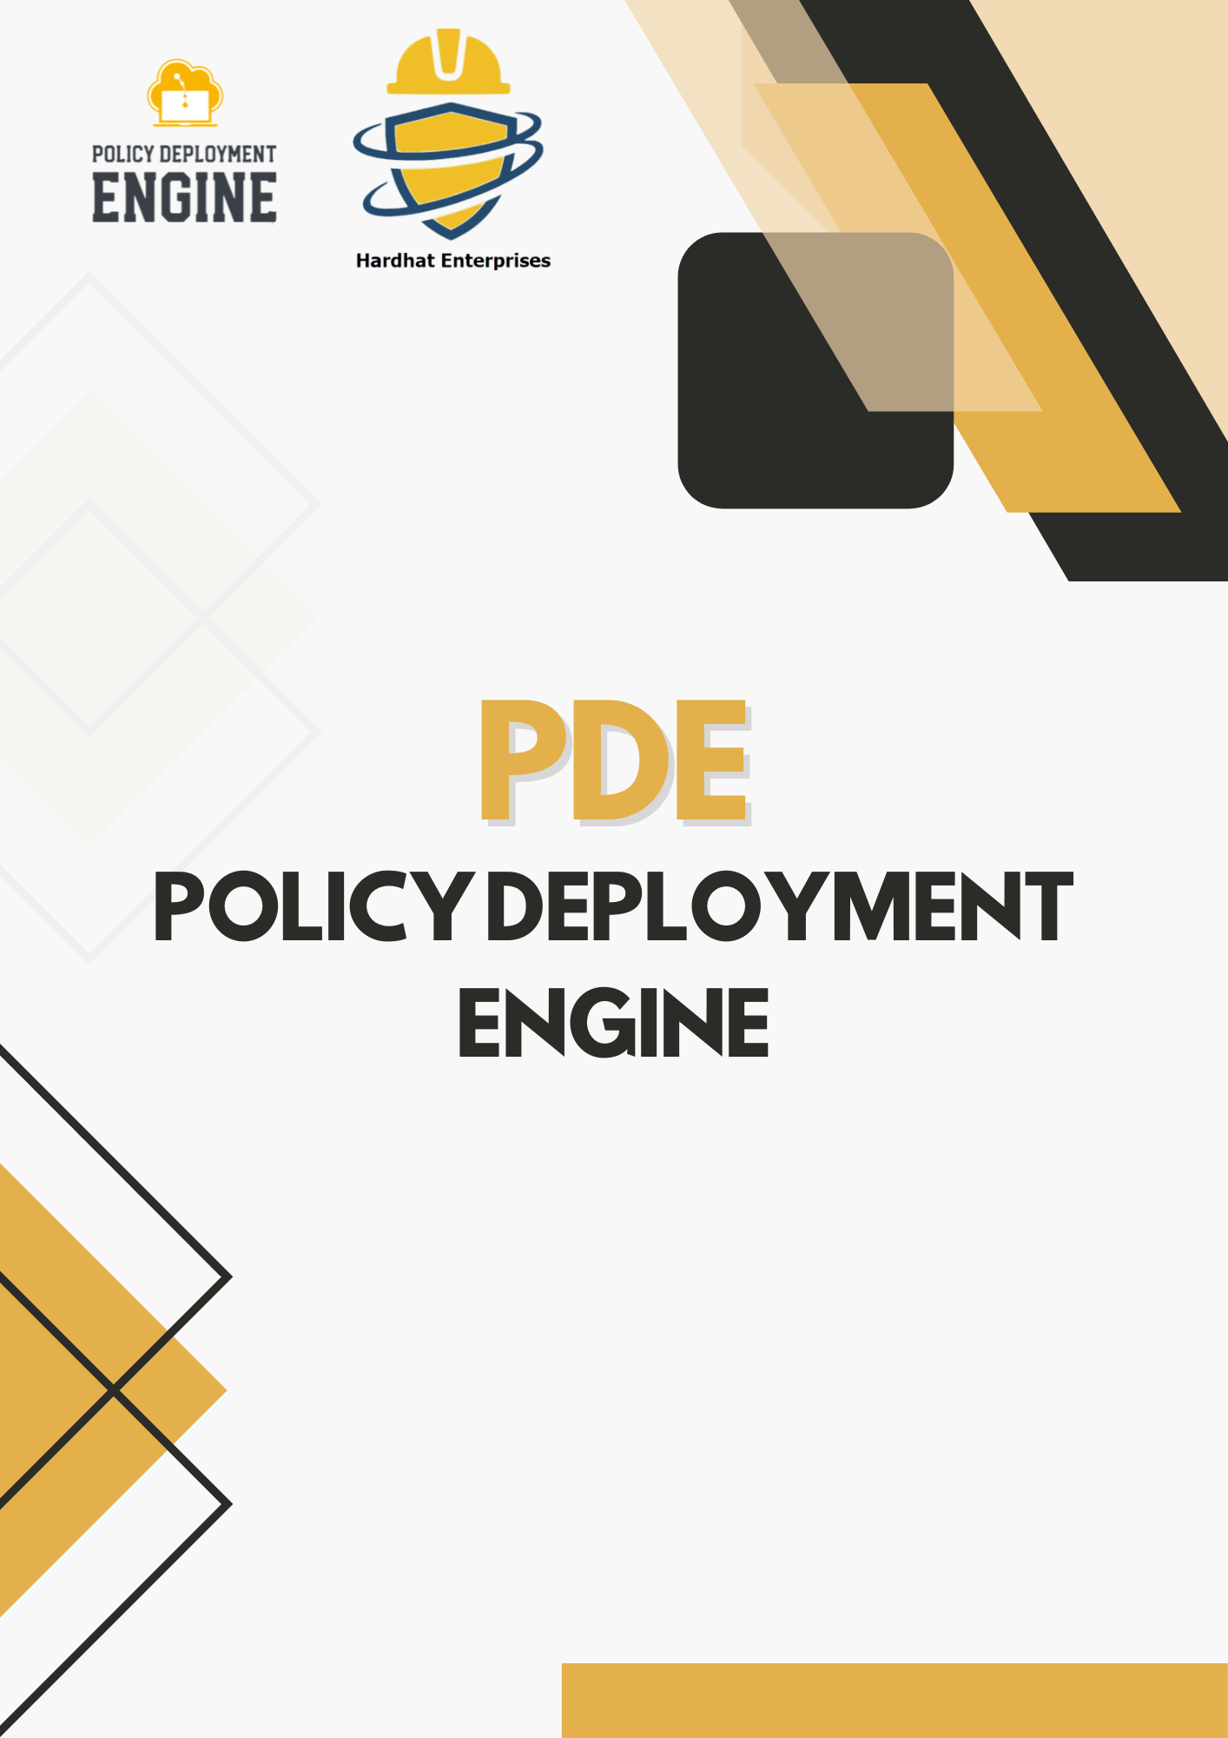
- Aaditya Kulkarni
- Student Id: 223309593
- Service: Secret Manager

Table of Contents
1. Service Overview 3
2. Resource Types 3
2.1.1 Policy: Annotations Required 4
2.1.2 Policy: CMEK Required 4
2.1.3 Policy: Destroy TTL Required 4
2.1.4 Policy: Labels Required 4
2.1.5 Policy: Region Redundancy Enforced 4
2.1.6 Policy: Rotation and TTL Enforced 4
2.1.7 Policy: Topic Attachment Required 4
2.1.8 Policy: TTL Enforced 4
2.2.1 Policy: IAM Conditions Enforced 4
2.2.2 Policy: Complex IAM Conditions Enforced 5
2.2.3 Policy: IAM Role Restrictions 5
2.2.4 Policy: Public Access Blocked 5
2.3.1 Policy: Base64 Encoding Required 5
2.3.2 Policy: Deletion Policy Whitelisted 5
2.3.2 Policy: Write-Only Data Flag Enforced 5
2.3.3 Policy: Rotation Period Required 5
3. Suggestions for Future Development 5

1. Service Overview
Google Cloud Secret Manager provides a secure and centralized way to manage secrets such as API keys, passwords, and certificates. It ensures sensitive data is protected through access controls, encryption, versioning, and auditing features that are critical for modern cloud-based security.

2. Resource Types
This policy suite applies to the following Secret Manager resource types:
- google_secret_manager_secret: The top-level secret container.
- google_secret_manager_secret_iam_binding: IAM bindings for who can access or manage a secret.
- google_secret_manager_secret_version: The actual data/version of a secret.
Each resource serves a unique purpose in controlling, storing, and auditing sensitive credentials.

2.1.1 Policy: Annotations Required
This policy ensures that metadata annotations like created_by and env are added to secrets. It helps with traceability, auditing, and environment identification during reviews or investigations.

2.1.2 Policy: CMEK Required
This policy enforces that secrets use a customer-managed encryption key (CMEK) instead of default Google-managed encryption. It improves compliance and gives organizations more control over cryptographic protection.

2.1.3 Policy: Destroy TTL Required
This policy checks that the version_destroy_ttl attribute is set. It ensures secrets aren’t deleted immediately upon destroy and provides a buffer for accidental deletions.

2.1.4 Policy: Labels Required
This policy enforces that at least one label is set for each secret. Labels help categorize secrets by team, purpose, or environment for easier governance and filtering.

2.1.5 Policy: Region Redundancy Enforced
This policy ensures that user-managed replication includes at least two regions. It protects against regional outages and ensures high availability of secrets.

2.1.6 Policy: Rotation and TTL Enforced
This policy requires that secrets have both rotation and TTL configurations. This helps reduce the risk of stale secrets being left active indefinitely.

2.1.7 Policy: Topic Attachment Required
This policy checks that at least one Pub/Sub topic is attached to secrets. This enables alerting or auditing workflows when changes occur.

2.1.8 Policy: TTL Enforced
This policy enforces that a TTL is specified for each secret. TTL ensures secrets are automatically expired, which helps with secret hygiene and lifecycle management.

2.2.1 Policy: IAM Conditions Enforced
This policy requires that IAM bindings use condition blocks. Conditions can restrict access using expiry dates or logical expressions, which prevents long-term overprivileged access.

2.2.2 Policy: Complex IAM Conditions Enforced
This policy enforces more advanced IAM conditions, including both expiry timestamps and weekday restrictions. It helps in tightly controlling access windows.

2.2.3 Policy: IAM Role Restrictions
This policy blocks the use of overly permissive roles like owner, editor, or viewer. It ensures only fine-grained roles like secretAccessor are used to follow the principle of least privilege.

2.2.4 Policy: Public Access Blocked
This policy prevents adding public members such as allUsers or allAuthenticatedUsers to secrets. It ensures secrets are not exposed unintentionally.

2.3.1 Policy: Base64 Encoding Required
This policy enforces that binary-like secret data is base64 encoded using is_secret_data_base64 = true. This helps maintain data integrity and avoids decoding errors.

2.3.2 Policy: Deletion Policy Whitelisted
This policy ensures deletion_policy is set to DISABLE or ABANDON instead of DELETE. It protects against permanent loss by allowing recovery time before deletion.

2.3.2 Policy: Write-Only Data Flag Enforced
This policy ensures sensitive data is stored using write-only fields (secret_data_wo). It prevents secrets from being exposed in plaintext via Terraform state or plan output.

2.3.3 Policy: Rotation Period Required
This policy enforces the presence of rotation_period to ensure secrets are rotated periodically. It helps minimize the window of exposure in case of leaks.

3. Suggestions for Future Development
- Require naming conventions for secrets to match project or environment tags.
- Detect secrets that haven’t been accessed in over 90 days for cleanup.
- Enforce specific key algorithms in CMEK policies (e.g., RSA vs. AES).
- Validate consistency between secret labels and their replication strategy.
- Flag secrets shared across multiple projects unless explicitly approved.
- Audit secrets with IAM bindings that override org-level restrictions.
- Enforce minimum TTL durations to prevent secrets from expiring too quickly.
- Require owner annotations to identify who is accountable for each secret.
- Enforce a 90-day maximum age for unrotated secrets.

